**1. INTRODUCTION**

* 1. OVERVIEW

In this project shows the process of voting and methods of voting.

There is an huge ideology of making votes

* 1. PURPOSE

Though this project we can understand the purpose of voting.

One of the achievements of this project is knowledge of voting

**2. PROBLEM DEFINITION & DESIGN THINKING**

2.1 Empathy map

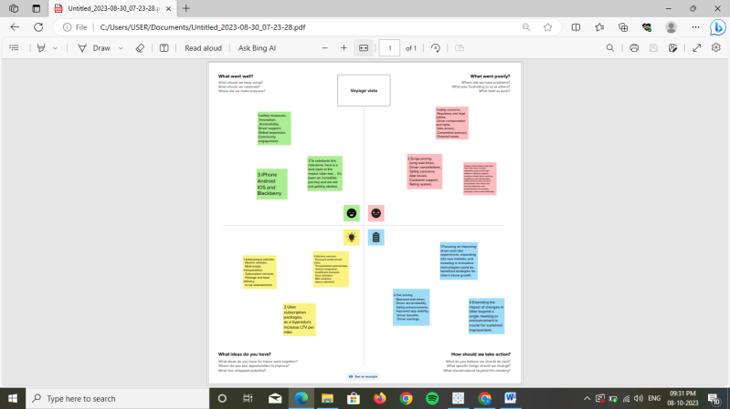

2.2 Ideation & Brainstorming map

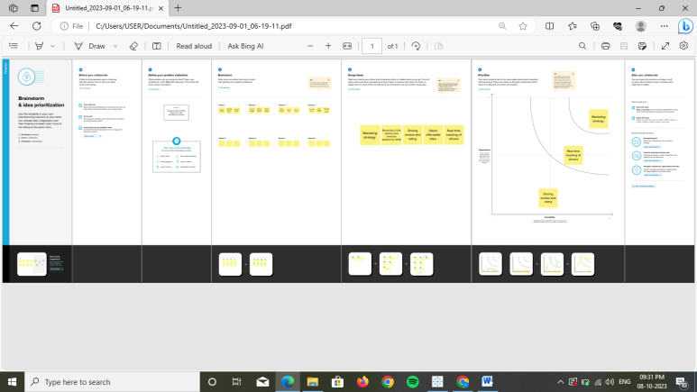

**3.RESULT**

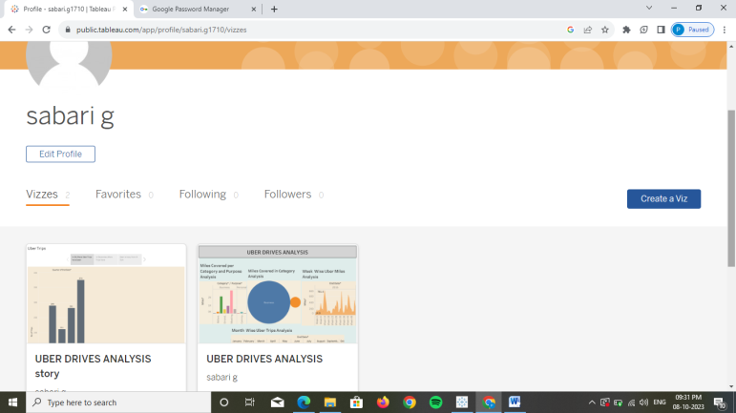

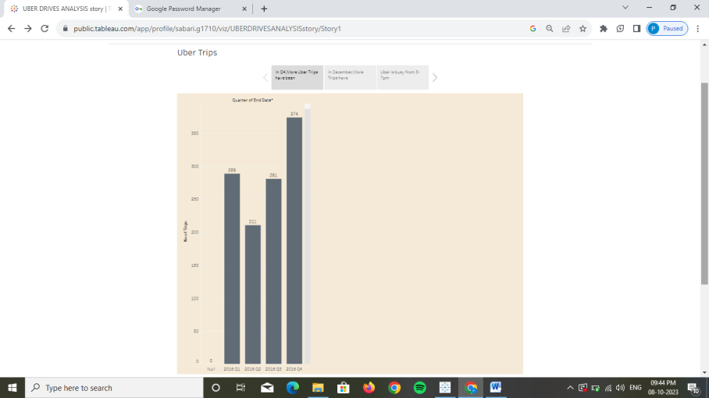

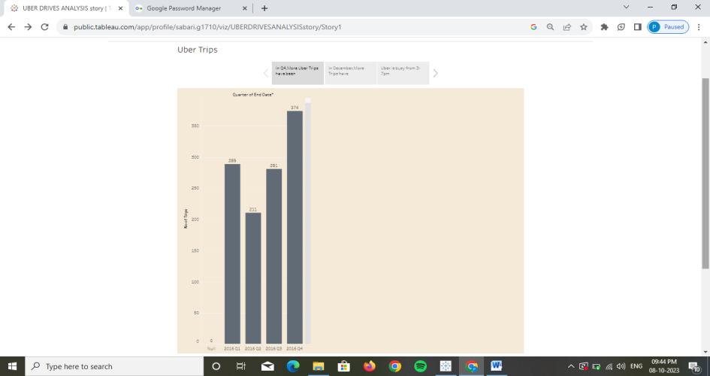

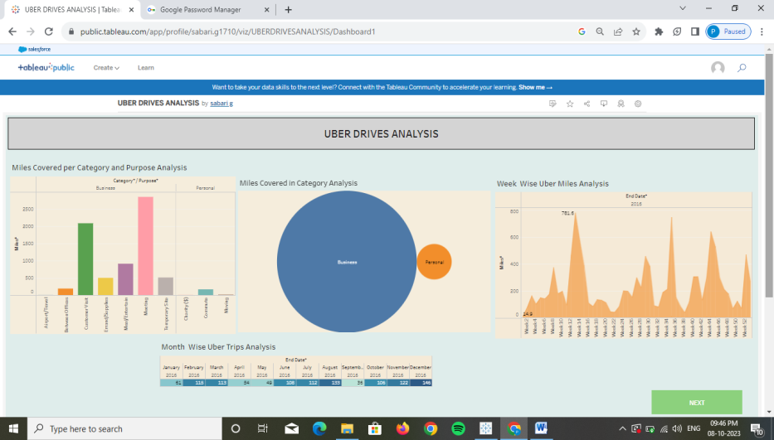

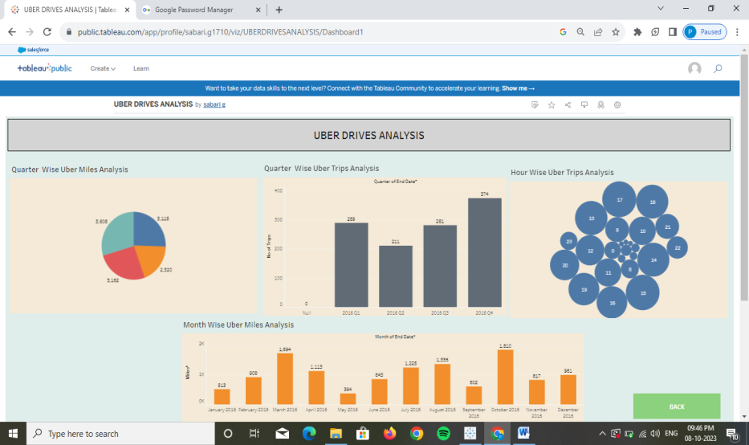

**4. ADVANTAGES & DISADVANTAGE**

* Uber provides a convenient way to request a ride via a mobile app, eliminating the need to hail a taxi or wait for public transportation.
* Uber operates in many cities worldwide, making it accessible in urban and suburban areas where taxis may be scarce.
* In many cases, Uber can be more cost-effective than traditional taxi services, especially for longer rides.
* During high-demand periods, Uber may implement surge pricing, leading to higher fares than usual.
* Uber has faced regulatory challenges and legal issues in some regions, leading to bans or restrictions in certain areas.

**5. APPLICATIONS**

Uber’s application extends beyond ride-hailing.it has expanded into food delivery (Uber Eats), freight logistics (Uber Freight), and autonomous vehicle development. The platform can also be used for last-mile transportation in public transit systems.

**6. CONCLUSION**

Uber has transformed the transportation and delivery industries, offering unparalleled convenience and flexibility. However, it’s not without its challenges, including safety concerns and regulatory hurdles. Nevertheless, it continues to innovate and expand its services, aiming to provide accessible and affordable transportation options to more people.

**7. FUTURE SCOPE**

* Uber can further invest in electric and autonomous vehicles to reduce its carbon footprint and enhance safety.
* Ongoing enhancements in safety features and driver screening can help build trust among users.
* Expanding to new cities and countries offers growth opportunities, but it also involves adapting to diverse regulations and market dynamics.